Developing your understanding 16.6

1 Compare the differences between the food available to the rich and the poor.

2 Compare the difference between the Legalist view of human nature and the Confucianist view.

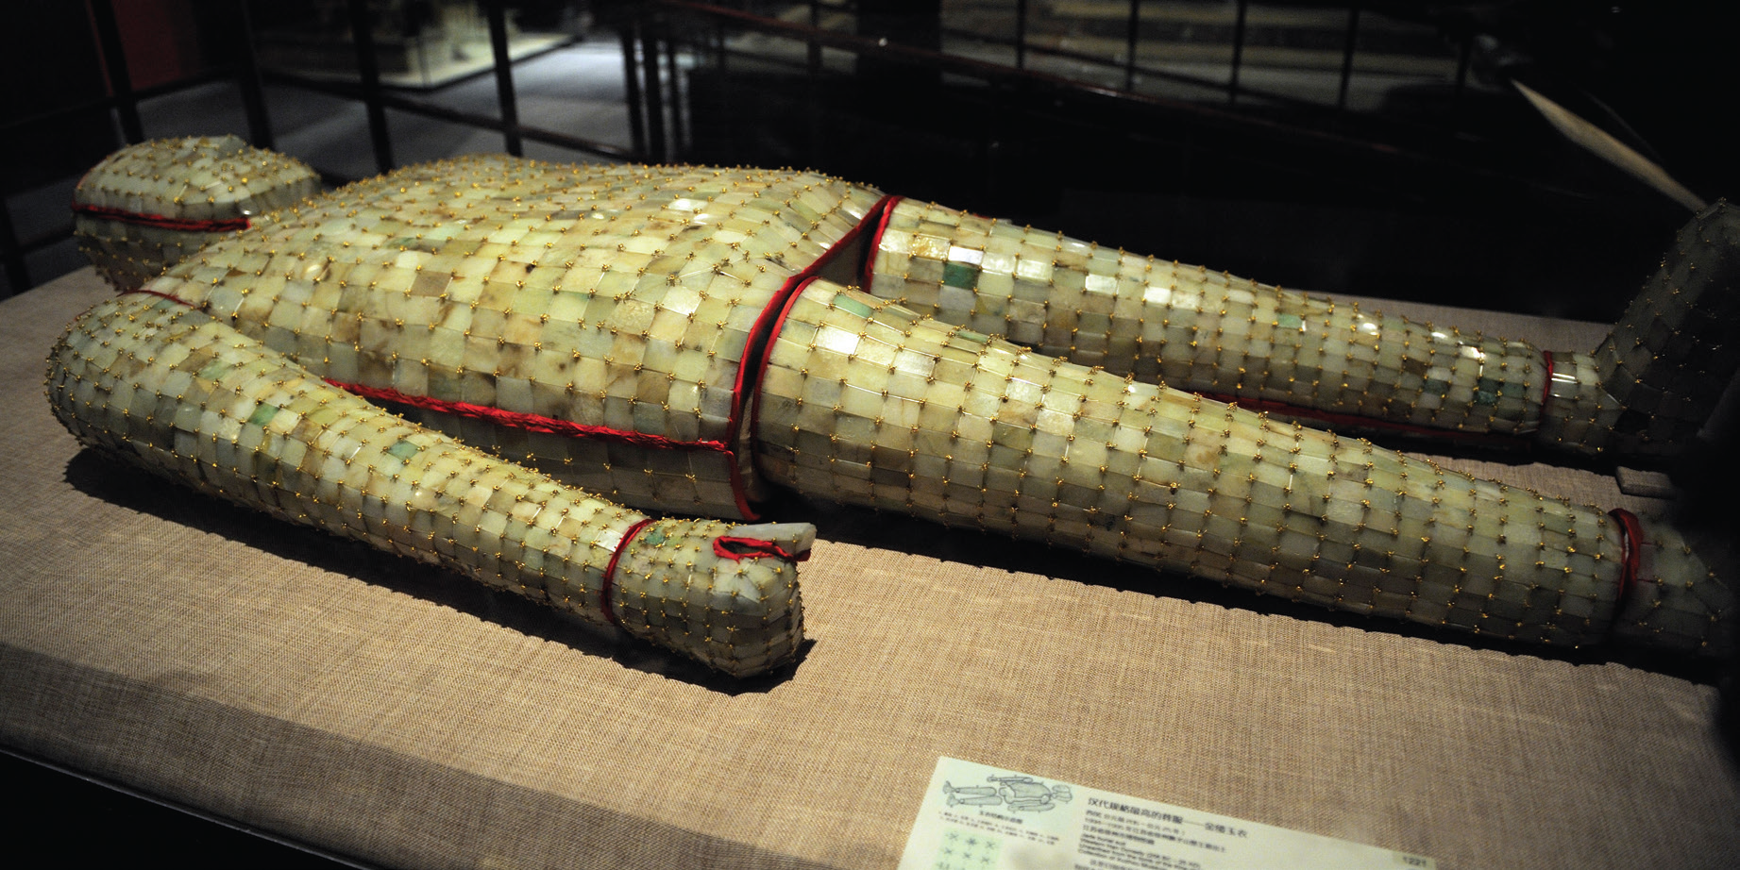
Source 16.12 This jade burial suit contained the body of Liu Sheng, brother of Emperor Han Wudi, who died in 113 BCE. The suit is made from over 2000 jade plates sewn together by gold wire. Jade had a very important role in ancient Chinese burials. Jade objects were placed on top of and around the body. The ancient Chinese came to believe that jade had the power to protect their bodies. Royal tombs from the Han dynasty onwards have contained bodies wearing jade burial suits, to protect the corpses from decay.

3 What were ancient Chinese attitudes about death? How does Source 16.12 relate to these?

4 Explain the role of women in ancient Chinese society. Look at women from different social classes. In your answer, make specific reference to at least two sources from this section to support your answer.

